**In-Patient**

P1: High Priority / P2: Medium Priority / P3: Low Priority

**Scenario 1 (P1):**

* User is unable to track easily previous claims notes from the main screen for “Medical File”, instead, user is requested to view “Actions” on each claim, which opens previous claim’s screen
* What if user has 50 claims to check?
* What is the difference between “Insurer Amount” and “Approved Est”

When user clicks on “view – Actions”, it should immediately show as a bot previous approval’s notes

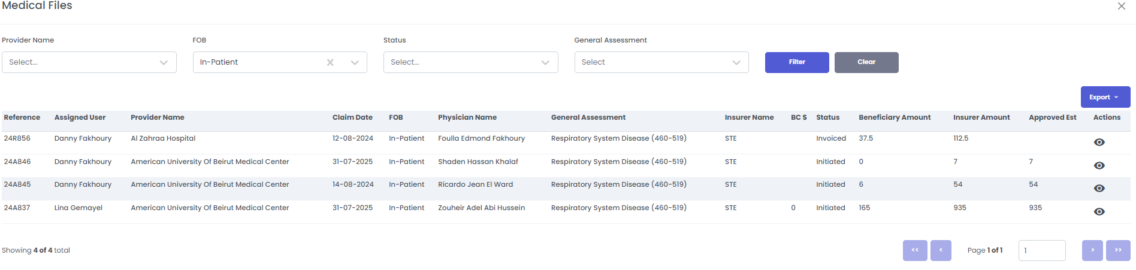

**Scenario 2 (P1):**

* If Estimation Amount $ (initial amount requested by provider) > Remaining Limit

Blocking message (PrtSc 1): The Estimation Amount cannot be greater than the Remaining Limit. Please check the Beneficiary’s Notes if any

User is unable to proceed unless Est. Amt. $ has been decreased. This is unusual practice, knowing that the Est. Amt. is the one initially requested by HCP, which we need to keep as is enabling proper calculation of savings (Requested Amt – Approved Amt)

🡪 In case the insured has specific limit:

* The calculation of Approved Est $ (Insurer’s Share) should read from Remaining Limit not from the Estimation Amount $
* System to auto-display the Approved Est $ taking into consideration the below:
* Remaining Limit
* Copay $
* Deductible Amount $
* Disapproved Amt $
* Special Coverage $
* If Estimation Amount $ < Remaining Limit

Blocking message (PrtSc 2 & 3): ~~The Estimation Amount cannot be greater than the Remaining Limit. Please check the Beneficiary’s Notes if any~~

**PrtSc 1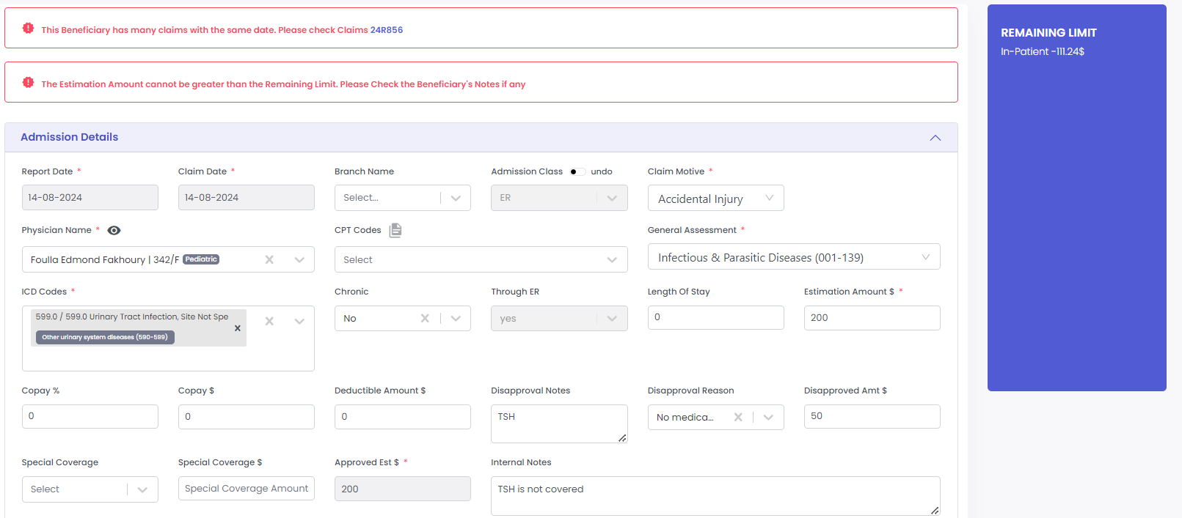PrtSc 2**

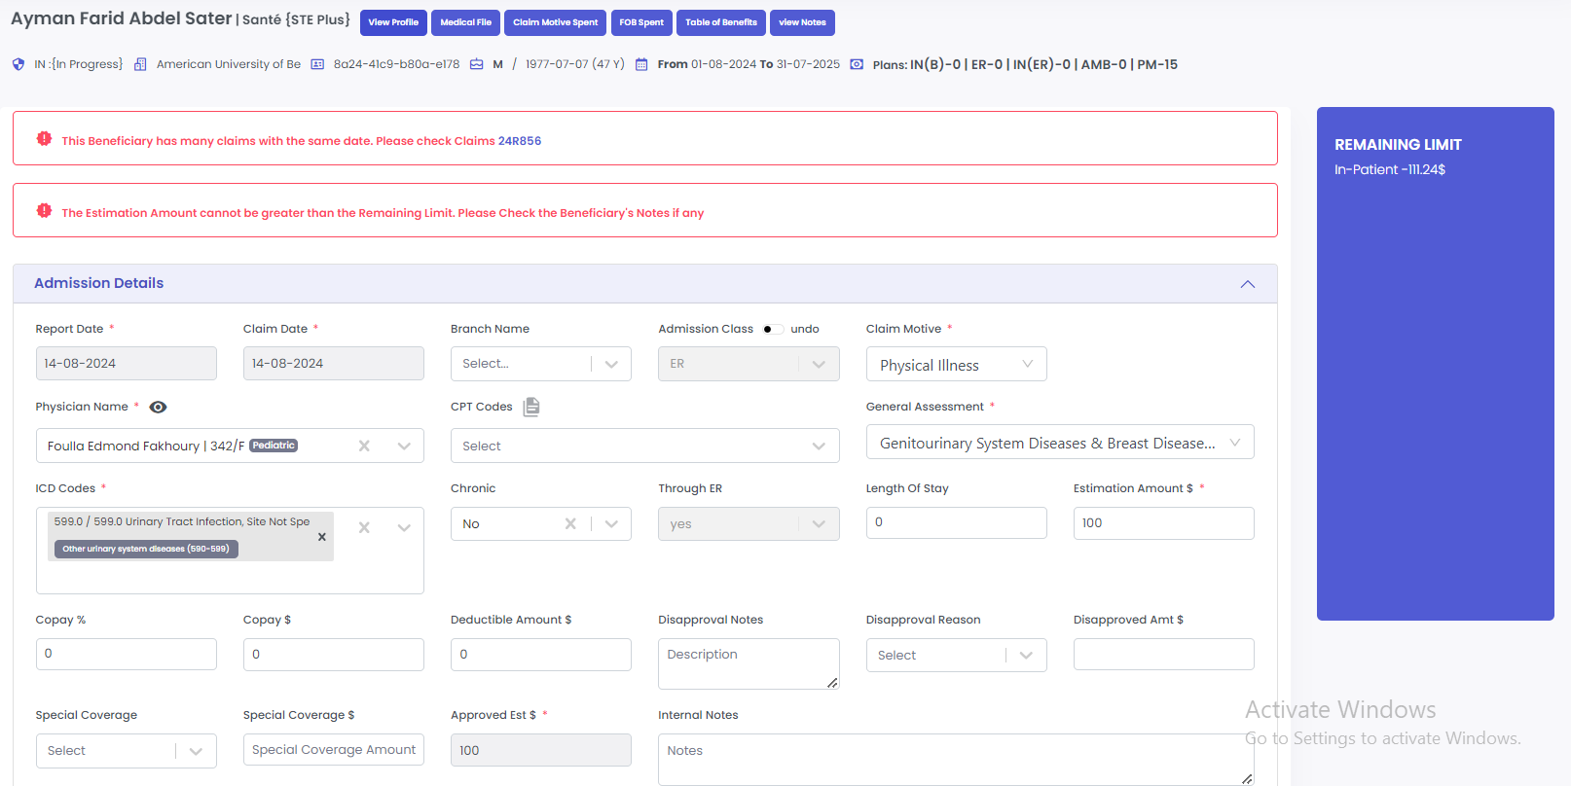

**PrtSc 3**

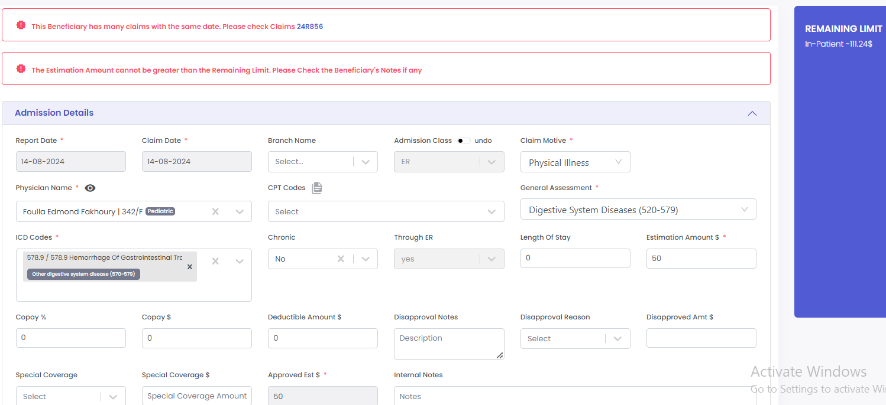

**Scenario 3 (P1):**

* Claim Date is 14-08-2024

Blocking message (PrtSc 1): “This Beneficiary has many claims with the same date. Please check Claims 24R856”

* 24R856 🡪 Claim Date is 12-08-2024. (PrtSc 2)
* System does not allow user to proceed

**PrtSc 1**

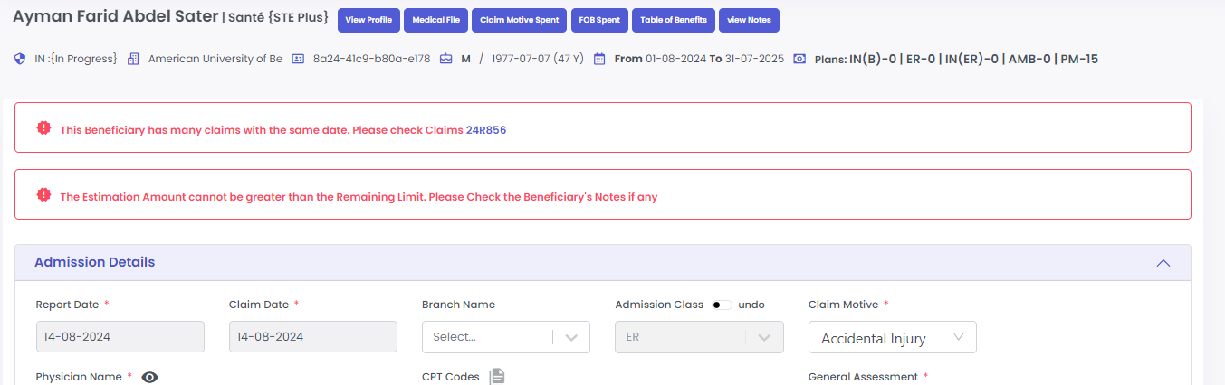

**PrtSc 2**

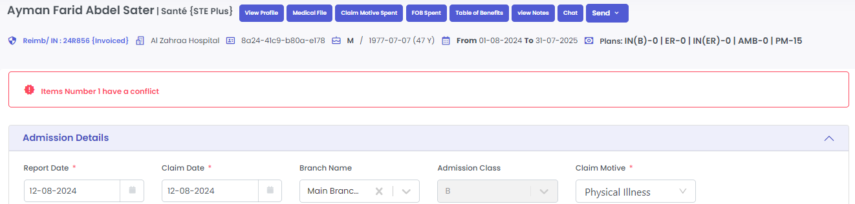

**Scenario 4 (P1):**

* In case of admission thru ER

Admission Class = ER + Through ER = Yes + Est. Amt. $ = 100

🡪 Results:

* Approval issued successfully
* “Admission Motive” on approval to be changed to “Admission Class”
* System did not auto-update the remaining limit which should be 187.26$ (287.26$ (remaining limit) - 100$ (ER Approved Est $))

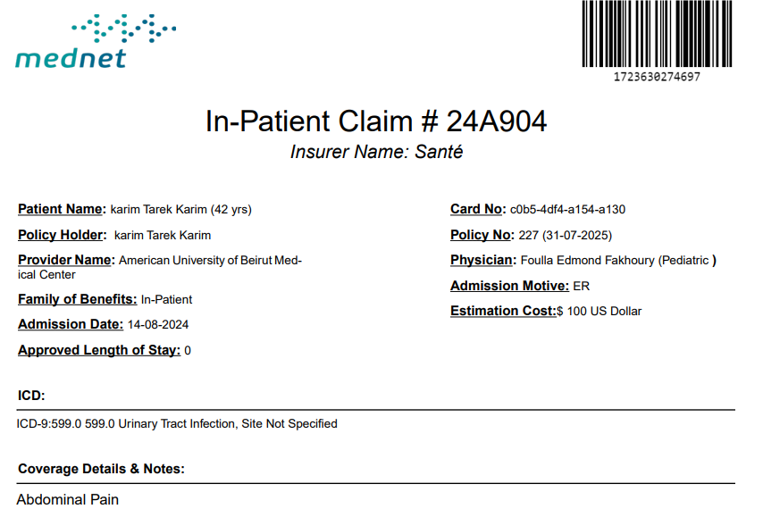

* Undo Admission Class = A + Through ER = Yes + LOS = 1 + Est. Amt. $ = 200$

🡪 Results:

* Claim successfully saved
* “Authorize” option disappeared from the Actions list
* System did not auto-update the remaining limit which should be 87.26$ (287.26$ (remaining limit) - 200$ (Admission Approved Est $))
* “Admission Motive” on approval to be changed to “Admission Class”
* Updated approval 🡪 LOS = 0 despite that updated LOS on system = 1



